The template is designed to help the submission of your article. For more detailed information about Nature Communications and its submission guidelines, please go to the journal’s official website.
- Nature Communications homepage: https://www.nature.com/ncomms
- Submission guidelines: https://www.nature.com/documents/ncomms-formatting-instructions.pdf
- Submission link: https://mts-ncomms.nature.com/cgi-bin/main.plex
- Information on editorial and authorship policies: https://www.nature.com/nature-research/editorial-policies/authorship
- Editorial and Publishing policies: https://www.nature.com/ncomms/journal-policies/editorial-publishing-policies
- All applications for discretionary article processing charge (APC) waivers should be made at the point of manuscript submission (apcwaivers@springernature.com)

Submission notes:
- Main text should have no more than 6,000 words and 10 display items (figures, tables).
- Cover letter is optional but encouraged.
- The Nature journals are flexible regarding the format of initial submissions. If revisions are requested, the editor will provide detailed formatting instructions at that time.
- For relevant manuscripts, you may be requested to provide a source data file in Microsoft Excel format or a zipped folder.
- For double-blind peer review, conceal the identities of all the authors, please click here.
- It is a requirement of submission that you alert the journal about any related manuscripts with overlapping authorship that are under consideration or in press at other journals (see editorial policies on duplicate submissions).
Title - should not contain technical terms, abbreviations, punctuation, and active verbs; max. 15 words
Author Information
Affiliations
School of Engineering and Material Science, Queen Mary University of London, London, UK
Author-1, Author-2 & Author-3
Process & Energy Department, Faculty of Mechanical, Maritime and Materials Engineering, Delft University of Technology, Delft, The Netherlands
Author-4
Contributions
You must include a statement that specifies the individual contributions of each co-author. For example: "A.P.M. ‘contributed’ Y and Z; B.T.R. ‘contributed’ Y,” etc. See our authorship policies for more details.
Corresponding author
Correspondence to: Author-4
Corresponding authors must provide their ORCID ID before resubmitting the final version of the manuscript. Non-corresponding authors are encouraged to link their ORCID.
Abstract
Max. of 150 words, unreferenced. Provide a general introduction to the topic and a brief nontechnical summary of the main results and their implication.

Introduction
Introduction should not include subheadings and should have referenced text^{1,2}. The Introduction expands on the background of the work, followed by sections headed Results, Discussion (if appropriate) and Methods (if appropriate). Footnotes are not used.
The manuscript can be written using Word or TeX/LaTeX file.

Results
For gene, protein, and other specialized names, taxonomic nomenclature, go to Formatting Guide – Readability.
Results subheading 1
The Results section should include subheadings.
Figure legend should total no more than 350 words. Figures may be inserted within the text at the appropriate positions or grouped at the end. Provide images in RGB colour and at 300 dpi or higher resolution. Avoid the use of red and green for contrast. Colour-safe combinations such as green and magenta, turquoise and red, yellow and blue. Use solid colour for filling objects; avoid hatch patterns or background shading. Display items that contain chemical structures should be produced using ChemDraw or a similar program.
Authors are responsible for obtaining permission to publish any figures or illustrations that are protected by copyright, including figures published elsewhere and pictures taken by professional photographers. You will receive more extensive instructions for final submission of display items after your article is accepted. Here are some guidelines for final figure preparation.

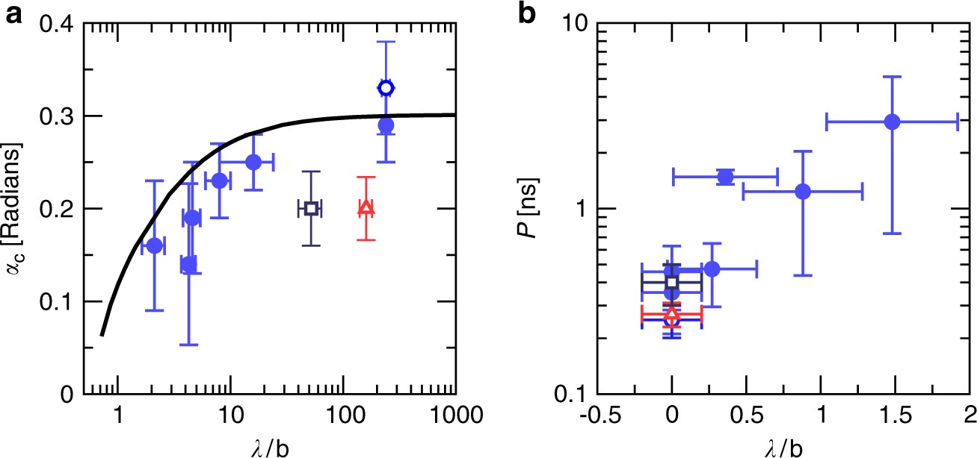
Fig. 1: Impact of the slip length on the platelet dynamics.

a Average angle α_{c} as a function of λ/b for a monolayer graphene platelet a = 1.7 nm. Data corresponds to pure graphene in water (open disk), pure graphene in NMP (open square), pure graphene in CPO (open triangle) and surface-modified graphene in water (full disks). Error bars on both α_{c} and λ correspond to standard deviations in MD measurements. b Average time period P of the orbit, as a function of λ/b. Data corresponds to a no-slip platelet in water (open disk), no-slip platelet in NMP (open square), no-slip platelet in CPO (open triangle) and surface-modified graphene in water (full disks). Error bars on P are the standard deviation measured on several rotations.

Results subheading 2
Equations and mathematical expressions should be provided in the main text of the paper. Equations that are referred to in the text are identified by parenthetical numbers, such as (1), and are referred to in the manuscript as "equation (1)".

${\left(x+a\right)}^{n}=\sum_{k=0}^{n}{\left({n \atop k}\right)x^{k}a^{n-k}}$ (1)

Discussion
The discussion should be succinct and should not contain subheadings.

Methods
Methods subheading 1
The Methods section should include subheadings. The Methods section appears in all online original research articles and should contain all elements necessary for interpretation and replication of the results.
Methods should be written as concisely as possible and typically do not exceed 3,000 words but may be longer if necessary. Nature Communications encourage you to deposit any step-by-step protocols used in your study in the Protocol Exchange.
Statistical information
The Methods must include a statistics section where you describe the statistical tests used and whether they were one- or two-tailed. Please ensure that the error bars are defined throughout the figures. For all statistics (including error bars), provide the EXACT n values used to calculate the statistics (reporting individual values rather than a range if n varied among experiments). For representative results, report the number of times that the measurements were repeated. Where relevant, provide exact values for both significant and non-significant P values. For ANOVAs, provide F values and degrees of freedom. For t-tests, provide t-values and degrees of freedom. Please specifically define the replicates.
Data Availability
For more information on data availability, click here. Certain data types must be deposited in an appropriate public structured data depository (details are available here) and the accession number(s) provided in the manuscript. Full access is required at acceptance. Should full access to data be required for peer review, authors must provide it. Nature Communications encourage provision of other source data in unstructured public depositories such as Dryad or figshare, or as supplementary information. To maximize data reuse, Nature Communications encourage publication of detailed descriptions of datasets in Scientific Data.
Code Availability
Research papers using custom computer code will also be asked to fill out a code and software submission checklist that will be made available to editors and reviewers during manuscript assessment. The aim is to make studies that use such code more reliable by ensuring that all relevant documentation is available and by facilitating testing of software by the reviewers. Further detailed guidance and required documentation at submission and acceptance of the manuscript can be found here.
References
References should be numbered sequentially first throughout the text, then in tables, followed by figures and, finally, boxes. References may only contain citations and should list only one publication with each number. Examples:
- For research articles, author list, title of paper. Name of journal volume number, initial-final page numbers (or article number) (year) are required. Example: Eigler, D. M. & Schweizer, E. K. Positioning single atoms with a scanning tunnelling microscope. Nature 344, 524-526 (1990).
- For Commentaries or News & Views, titles of cited articles are not included. Example: Iijima, S. Nature 354, 56-58 (1991).
- For book citations, the publisher and city of publication are required. Example: Jones, R. A. L. Soft Machines: Nanotechnology and Life Ch. 3 (Oxford Univ. Press, Oxford, 2004).
- Research datasets may be cited in the reference list if they have been assigned digital object identifiers (DOIs) and include authors, title, publisher (repository name), identifier (DOI expressed as a URL). Example:
- Hao, Z., AghaKouchak, A., Nakhjiri, N. & Farahmand, A. Global Integrated Drought Monitoring and Prediction System (GIDMaPS) data sets. figshare http://dx.doi.org/10.6084/m9.figshare.853801 (2014).
- To cite a preprint, please follow this style: Babichev, S. A., Ries, J. & Lvovsky, A. I. Quantum scissors: teleportation of single-mode optical states by means of a nonlocal single photon. Preprint at http://arXiv.org/quant-ph/0208066 (2002).
Acknowledgements (optional)
Keep acknowledgements brief and do not include thanks to anonymous referees or editors, or effusive comments. Grant or contribution numbers may be acknowledged.
Ethics declarations
Competing interests
Submission of a competing interests statement is required for all content of the journal.
Supplementary Information
Supplementary Information: should be combined and supplied as a separate file, preferably in PDF format.
Supplementary information includes:
- material that is essential background, but which is too large, impractical or specialised to justify inclusion in the PDF version of the paper.
- tables larger than one page (in general, >50 rows or >10 columns) should be provided as tabular data files rather than a PDF.
- video files (avi, mov, mp4 or mpg) - use H.264 encoding, aspect ratio of 16:9 (4:3 is second best), and do not compress the video.
- data sets relating to the characterization of chemical compounds.

Tables
Please submit tables at the end of your text document. Tables that include statistical analysis of data should describe their standards of error analysis and ranges in a table legend. Tables larger than one page (in general, >50 rows or >10 columns) should be provided as tabular data files.

Table 1 Slip length λ as measured from MD
Surface | Solvent | λ (nm)
Graphene | Water | 60.0 ± 5.0
Graphene | CPO | 40.0 ± 5.0
GO (1%) | Water | 4.0 ± 2.0
GO stands for graphene-oxide and the percentage is the ratio between oxygen and carbon atoms.

