The template is designed to help the submission of your article. For more detailed information about BMC Medicine and its submission guidelines, please go to the journal’s official website.
- BMC Medicine homepage
- Submission guidelines
- Submission link: https://www.editorialmanager.com/bmed/default.aspx
- Information on fees and funding
- Editorial and Publishing policies

Submission notes:
- Your manuscript must include a 'Declarations' section with all its subsections even those that are not applicable to your study. For those, you simply state ‘Not applicable’.
- Use double line spacing, include line and page numbering, do not use page breaks in your manuscript
- Use SI units: Please ensure that all special characters used are embedded in the text, otherwise they will be lost during conversion to PDF
- The Abstract should not exceed 350 words. Please minimize the use of abbreviations and do not cite references in the abstract. Reports of randomized controlled trials should follow the CONSORT extension for abstracts. The abstract must include the following separate sections: Background, Methods, Results, Conclusions, and Trial Registration.
- The following word processor file formats are acceptable for the main manuscript document: Microsoft word (DOC, DOCX), Rich text format (RTF), TeX/LaTeX (use BioMed Central's TeX template)
- Note that editable files are required for processing in production.
- Footnotes can be used to give additional information.

Title Page
The title page should:
- present a title that includes, if appropriate, the study design, e.g.:
  - "A versus B in the treatment of C: a randomized controlled trial", "X is a risk factor for Y: a case control study", "What is the impact of factor X on subject Y: A systematic review"
  - or for non-clinical or non-research studies, a description of what the article reports
- list the full names and institutional addresses for all authors​​​​​​​
  - if a collaboration group should be listed as an author, please list the Group name as an author. If you would like the names of the individual members of the Group to be searchable through their individual PubMed records, please include this information in the “Acknowledgements” section in accordance with the instructions below
- indicate the corresponding author
Article Title
Firstname-1 Lastname-1, Firstname-2 Lastname-2, Firstname-3 Lastname-3 & Firstname-4 Lastname-4*
Abstract
Background
Describe the context and purpose of the study.
Methods
In this section, describe how the study was performed and what statistical tests were used.
Results
Write the main findings.
Conclusions
Present a brief summary and potential implications.
Trial registration
If your article reports the results of a health care intervention on human participants, it must be registered in an appropriate registry and the registration number and date of registration should be stated in this section. If it was not registered prospectively (before enrollment of the first participant), you should include the words 'retrospectively registered'. See our editorial policies for more information on trial registration.
Keywords
Three to ten keywords representing the main content of the article.

Background
The Background section should explain the background to the study, its aims, a summary of the existing literature and why this study was necessary or its contribution to the field.

Methods
The methods section should include:
- the aim, design and setting of the study,
- the characteristics of participants or description of materials,
- a clear description of all processes, interventions, and comparisons. Generic drug names should generally be used. When proprietary brands are used in research, include the brand names in parentheses,
- the type of statistical analysis used, including a power calculation if appropriate.

Results
This section should include the findings of the study including, if appropriate, results of statistical analysis which must be included either in the text or as tables (Table 1) and figures (Fig.1).
For details on how to prepare figures, visit here.
For additional information on how to prepare tables, visit here

Fig. 1
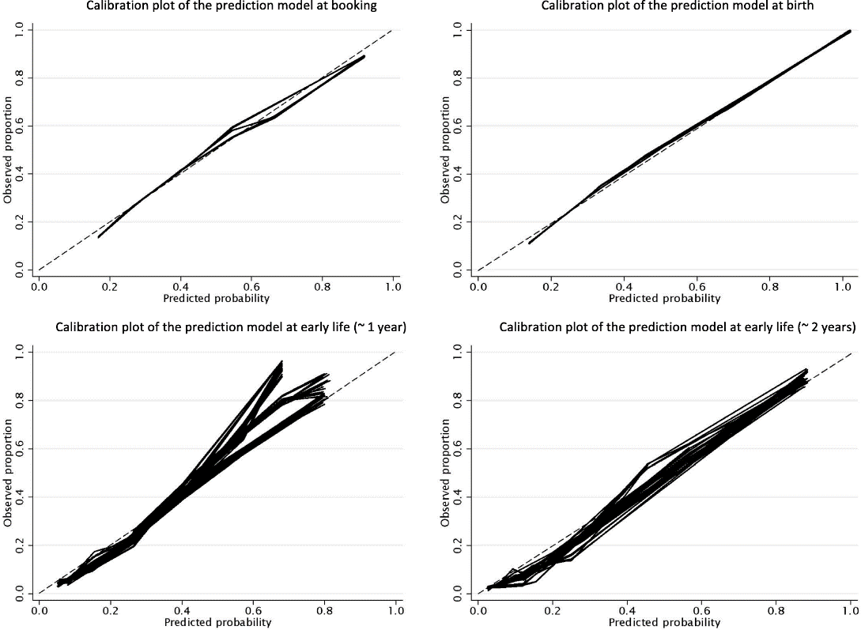
a–d Calibration plot of the prediction model at booking, birth, early life (~ 1 year), and early life (~ 2 years)

Table 1 Table title (max 15 words). Legend (max 300 words) should be included underneath the table
Characteristics | Group A | Group B | Group A+B | Group C
Age (years) | 3.0 (0.9–7.5) | 1.0 (1.0–4.5) | 1.0 (1.0–4.5) | 1.0 (1.0–4.5)
> 2.5 | 22/43 (51%) | 21/43 (49%) | 21/43 (49%) | 21/43 (49%)
≤ 2.5 | 21/43 (49%) | 4/7 (57%) | 4/7 (57%) | 4/7 (57%)
Sex
male | 23/43 (53%) | 5/7 (71%) | 5/7 (71%) | 5/7 (71%)
female | 20/43 (47%) | 2/7 (29%) | 2/7 (29%) | 2/7 (29%)
Clinical status
Asymptomaticª | 0/43 (0%) | 2/7 (29%) | 2/50 (4%) | 0/26 (0%)
Very mild | 0/43 (0%) | 5/7 (71%) | 5/50 (10%) | 0/26 (0%)
Mild | 41/43 (95%) | 0/7 (0%) | 41/50 (82%) | 26/26 (100%)
Severe | 0/43 (0%) | 0/7 (0%) | 0/50 (0%) | 0/26 (0%)
Critically ill | 2/43 (5%) | 0/7 (0%) | 2/50 (4%) | 0/26 (0%)
Symptoms
Fever | 29/43 (67%) | 3/7 (43%) | 32/50 (64%) | 21/26 (81%)
Cough | 21/43 (49%) | 1/7 (14%) | 22/50 (44%) | 19/26 (73%)
Myalgia/fatigue | 2/43 (5%) | 0/7 (0%) | 2/50 (4%) | 0/26 (0%)
Sore throat | 1/43 (2%) | 0/7 (0%) | 1/50 (2%) | 0/26 (0%)
Diarrhea | 3/43 (7%) | 0/7 (0%) | 3/50 (6%) | 0/26 (0%)
ªNo clinical symptoms and no abnormal CT findings
Results that would otherwise be indicated as "data not shown" should be included as additional files. BioMed Central requires that supporting data are included as additional files or deposited in a recognized repository. The maximum file size for additional files is 20 MB each. Each additional file should be cited in sequence within the main body of text. For more information on additional files, visit here
Discussion
This section should discuss the implications of the findings in context of existing research and highlight limitations of the study.
Conclusions
This should state clearly the main conclusions and provide an explanation of the importance and relevance of the study reported.
List of Abbreviations
If abbreviations are used in the text, they should be defined in the text at first use, and a list of abbreviations should be provided as below:
3Di: Developmental, Dimensional and Diagnostic Interview
ABC: Antecedents, Behaviours and Consequences (chart)
ACE: ADHD Child Evaluation
Declarations
All manuscripts must contain the following sections under the heading 'Declarations': Ethics approval and consent to participate, Consent for publication, Availability of data and materials, Competing interests, Funding, Authors' contributions, Acknowledgements, and Authors' information (optional). If any of the sections are not relevant to your manuscript, please include the heading and write 'Not applicable' for that section.
Ethics approval and consent to participate
Manuscripts reporting studies involving human participants, human data or human tissue must:
- include a statement on ethics approval and consent (even where the need for approval was waived)
- include the name of the ethics committee that approved the study and the committee’s reference number if appropriate
Studies involving animals must include a statement on ethics approval and for experimental studies involving client-owned animals, authors must also include a statement on informed consent from the client or owner. For more information, visit here.
Consent for publication
If your manuscript contains any individual person’s data in any form (including any individual details, images or videos), consent for publication must be obtained from that person, or in the case of children, their parent or legal guardian. All presentations of case reports must have consent for publication.
You can use your institutional consent form or our consent form if you prefer. You should not send the form to us on submission, but we may request to see a copy at any stage (including after publication).
For more information on consent for publication, visit here .
Availability of data and materials
All manuscripts must include an “Availability of Data and Materials” statement in their manuscript detailing where the data supporting their findings can be found. For more information, visit here
Competing interests
All financial and non-financial competing interests must be declared in this section. Please use the authors initials to refer to each authors' competing interests in this section. If you do not have any competing interests, please state "The authors declare that they have no competing interests" in this section.
Funding
All sources of funding for the research reported should be declared. The role of the funding body in the design of the study and collection, analysis, and interpretation of data and in writing the manuscript should be declared.
Authors’ Information
Affiliations
School of Engineering and Material Science, Queen Mary University of London, London, UK
Author-1, Author-2 & Author-3
Process & Energy Department, Faculty of Mechanical, Maritime and Materials Engineering, Delft University of Technology, Delft, The Netherlands
Author-4
Contributions
You must include a statement that specifies the individual contributions of each co-author. For example: "A.P.M. ‘contributed’ Y and Z; B.T.R. ‘contributed’ Y,” etc. See our authorship policies for more details.
Corresponding author
Correspondence to: Author-4
Acknowledgements
Please acknowledge anyone who contributed towards the article who does not meet the criteria for authorship including anyone who provided professional writing services or materials. Authors should obtain permission to acknowledge from all those mentioned in the Acknowledgements section. For more information, visit here.
Group authorship (for manuscripts involving a collaboration group): if you would like the names of the individual members of a collaboration Group to be searchable through their individual PubMed records, please ensure that the title of the collaboration Group is included on the title page and in the submission system and also include collaborating author names as the last paragraph of the “Acknowledgements” section. Please add authors in the format First Name, Middle initial(s) (optional), Last Name. You can add institution or country information for each author if you wish, but this should be consistent across all authors.
References
Examples of the Vancouver reference style are shown below:
Article within a journal
- Smith JJ. The world of science. Am J Sci. 1999;36:234-5.
Article within a journal (no page numbers)
- Rohrmann S, Overvad K, Bueno-de-Mesquita HB, Jakobsen MU, Egeberg R, Tjønneland A, et al. Meat consumption and mortality - results from the European Prospective Investigation into Cancer and Nutrition. BMC Medicine. 2013;11:63.
Article within a journal by DOI
- Slifka MK, Whitton JL. Clinical implications of dysregulated cytokine production. Dig J Mol Med. 2000; doi:10.1007/s801090000086.
Article within a journal supplement
- Frumin AM, Nussbaum J, Esposito M. Functional asplenia: demonstration of splenic activity by bone marrow scan. Blood 1979;59 Suppl 1:26-32.
Book chapter, or an article within a book
- Wyllie AH, Kerr JFR, Currie AR. Cell death: the significance of apoptosis. In: Bourne GH, Danielli JF, Jeon KW, editors. International review of cytology. London: Academic; 1980. p. 251-306.
OnlineFirst chapter in a series (without a volume designation but with a DOI)
- Saito Y, Hyuga H. Rate equation approaches to amplification of enantiomeric excess and chiral symmetry breaking. Top Curr Chem. 2007. doi:10.1007/128_2006_108.
Complete book, authored
- Blenkinsopp A, Paxton P. Symptoms in the pharmacy: a guide to the management of common illness. 3rd ed. Oxford: Blackwell Science; 1998.
Online document
- Doe J. Title of subordinate document. In: The dictionary of substances and their effects. Royal Society of Chemistry. 1999. http://www.rsc.org/dose/title of subordinate document. Accessed 15 Jan 1999.
Online database
- Healthwise Knowledgebase. US Pharmacopeia, Rockville. 1998. http://www.healthwise.org. Accessed 21 Sept 1998.
Supplementary material/private homepage
- Doe J. Title of supplementary material. 2000. http://www.privatehomepage.com. Accessed 22 Feb 2000.
University site
- Doe, J: Title of preprint. http://www.uni-heidelberg.de/mydata.html (1999). Accessed 25 Dec 1999.
FTP site
- Doe, J: Trivial HTTP, RFC2169. ftp://ftp.isi.edu/in-notes/rfc2169.txt (1999). Accessed 12 Nov 1999.
Organization site
- ISSN International Centre: The ISSN register. http://www.issn.org (2006). Accessed 20 Feb 2007.
Dataset with persistent identifier
- Zheng L-Y, Guo X-S, He B, Sun L-J, Peng Y, Dong S-S, et al. Genome data from sweet and grain sorghum (Sorghum bicolor). GigaScience Database. 2011. http://dx.doi.org/10.5524/100012.

